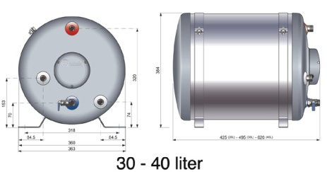

Jeanneau Sun Odyssey 36i (2008)
After gaining access, turn off power & remove plug from socket. Remove the top boiler to engine hose. Plug hose to stop any further drainage!
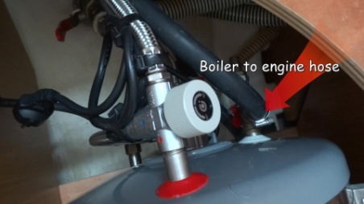
Now remove the HOT water flexi hose.
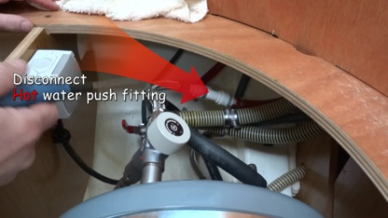
Remove COLD water flexi hose.
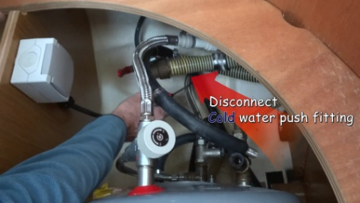
Remove bolts from securing straps.
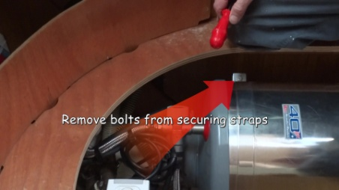
Open drain tap & allow boiler to empty into bilge.
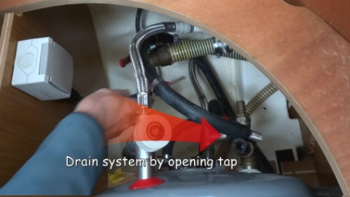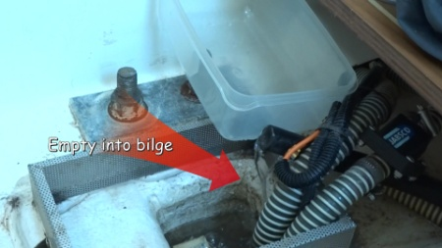
Now carefully stand boiler up, easing the drainage hose back from the bilge. We attached a rope to the bilge end to help with feeding it back through the bulkheads, when replacing the boiler.
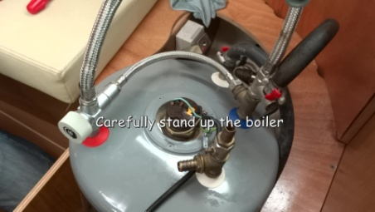
Remove wiring cover, disconnect wiring to the thermostat, & remove thermostat unit. Careful not to damage lugs underneath!
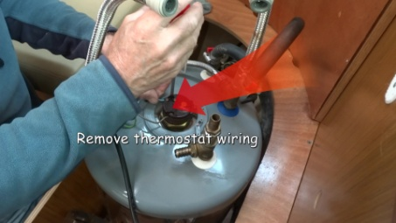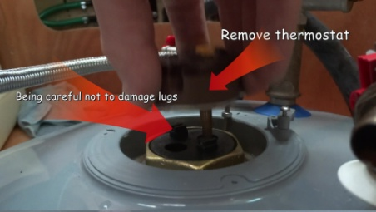
Using either a box spanner of as we did a large wrench, unscrew the element.
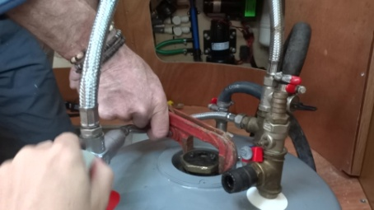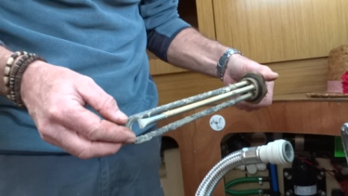
Check that the new element is correct and fit to boiler. The new element came with 2 seals, one ‘O’ ring and & a second flat seal! We used the ‘O’ ring, the same as the old one had fitted.
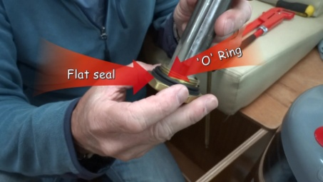
Screw in new element, & refit thermostat.
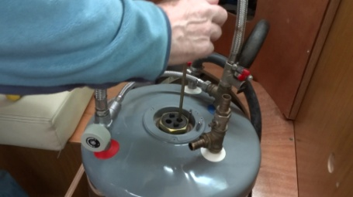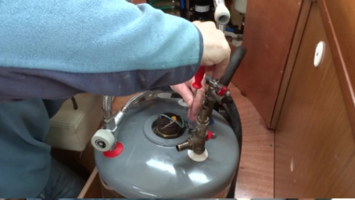
It is a good idea before lowering the boiler back in, to reconnect wiring and replace cover. We plugged ours into the 240v and checked it was working before going any further.
Once lowered back into place just reverse the removal process.
We hope this walkthrough has been helpful?
If you would like to watch the video walkthrough, please go to our YouTube channel at:
https://www.youtube.com/watch?v=0Y1VfT8iask
Sailing Kejstral Adventures

